

**The A Team**

**Image Processing Tool for**

**Leidenfrost-Ratchet Systems**

**Plan Document for Version 2.0 (Final Draft)**

March 5, 2014

**Authored By:**

Sanan Aamir

Romando Garcia

Anne Lam

James Rowe

Hieu Tran

Table of Contents

1. Introduction 2
   1. Purpose of Plan Document 2
   2. Project Scope and Objectives 2
      1. Statement of Scope 2
      2. Major Functions 2
   3. Overview of Document 3
2. Project Organization 3
   1. Process Model 3
   2. Team Structure 4
   3. Communication 4
   4. Reporting 4
3. Project Resources 4
   1. .People 4-5
   2. . Hardware and Software 5
4. Risk Management 5
   1. .Likely Risks 5
   2. . Risk Management Plan 6

5. Schedule 6

5.1. Task List and Resource Allocation 7, Appendix A

5.2. Time Line 7, Appendix B

5.3. Task Network Diagram 8, Appendix C

5.4. Objective Grading Sheet 8, Appendix D

6. Tracking and Control Mechanics 8

7. Glossary 9

8. References 9

**1. Introduction/Overview**

The plan document details the project planning for the entire development process.

1.1 Purpose of Plan Document

This plan document will set out the resources available to the project, the work breakdown, and the schedule of work for the second version of the Image Processing Tool.

1.2 Project Scope and Objectives

The scope comprises what we intend to implement and nothing more. The software's current capacity is to efficiently track a drop of liquid and record measurements through images gathered from a high speed camera as it falls from an injection needle and travels along a ratchet surface. We intend to add to this according to the following sections.

. Systeml is pixels to real world distances tool tips/intuitive usesequencege in the sequencetion of the needle and surface lo1.2.1 Statement of Scope

The main objectives of this edition of the tool are to increase automation, improve the user interface, provide graphical data, and speed up processing.

1.2.2 Major Functions

Specific functions to be brought up in this version include:

* Automatic determination of needle and ratchet location
  + if camera position is constant, determine location once using first image in sequence
  + if camera position is altered, determine location for each image in sequence
* Removal of the base image calibration
* Alteration of drop image manipulation (remove white glare)
* Drop volume measurement for each image
* Graphing of various plots using the extracted data
* Improvements to the user interface, including tool tips/intuitive use
* Increased processing efficiency
* Conversion of pixels to real world distances

1.3 Overview of Document

This document restates the project’s objectives. Moreover, it follows with the project’s organization, resources, potential risks and plan for management.

**2. Project Organization**

The project organization describes the framework of members and our process for implementation.

2.1 Process Model

The team will follow the Waterfall software development life cycle, following the organization laid out in Figure 1 which displays with communication, planning, modeling construction, and deployment stages. This decision was made due to its simple use and easy to understand style. Also, the requirements are well established and unlikely to be significantly changed.

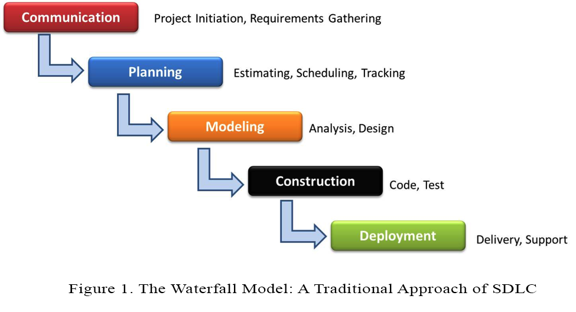

2.2 Team Structure

Team organization will be controlled and decentralized. The team includes James Rowe as project leader, but executive decision making will not be actively exercised. Everyone in the team inputs their ideas and opinions and decides best paths of actions together with James having the final say. Additionally, all members contribute to documentation via primary authoring or editing. Coding will be split based on functionality, with two pairs of partners focusing on a particular set of features. James/Romando Garcia and Anne Lam/Sanan Aamir comprise the partners and Hieu Tran will focus on testing and documentation.

2.3 Communication

Communication will be achieved through a variety of pathways. Weekly meet-ups at the library for the entire team are planned to ensure adequate and correct work is being done. Email, Github, and texting are the main secondary avenues for communication. Additionally, quick meetings in class will ensure focus and serve to remind members of impending tasks to be completed.

2.4 Reporting

Reporting of progress will be done during meetings to all members, to the leader, or through Github issue tracking. Additionally, interim and final reports/presentationsgiven to Dr. Stringfellow and the Software Engineering class will mark our progress.

**3. Project Resources**

The resources to the project include the development team members and the hardware and software required to accomplish the development of the tool.

3.1 People

James Rowe is acting project leader and will perform the supervising role while giving final say for split decisions. In addition, he and Romando will handle implementation of displaying frame rate in the Excel sheet, plotting the data in Excel with automatic graph generation, designing the User Interface, and handling inconsistent image locations. Anne will do the primary authoring of the documentation with assistance from Hieu, while the rest of the team reviews the documents. Anne and Sanan will implement the conversion of pixels to real world units, calculate drop volume and net measurements for velocity and acceleration, and fine-tune resulting locations of the needle and surface. Hieu is responsible for diagrams, testing and any additional needs as they come up.

3.2. Hardware and Software

Hardware use involves our personal laptops or desktops where documentation and code will be written. The Leidenfrost experiment’s set-up and the hardware associated are not included as the experiment has been completed and put away for the time-being.

Visual Studio, Git, and currently undetermined testing software will be used to aid our software development.

**4. Risk Management**

As with any endeavor, there are risks associated that may impede or impact the quality of this product. Recognizing the following potential risks, the team intends to prepare and work as organized and proactive as possible.

4.1 Likely Risks

We believe we may face these common obstacles:

* division of focus because of other responsibilities
* poor communication between team members
* poor time management of specific tasks
* scheduling conflicts between team members and possibly the client
* unforeseen emergencies involving health, family, etc.

4.2 Risk Management Plan

To avoid or alleviate the effects of the previously mentioned risks, the team has identified a few management techniques. These include performing proactive and focused work when given the opportunity, good organization, and constant communication. Table 1 below organizes our assessment and plan for the potential risks.

**Table 1.** Potential obstacles that may risk the successful completion of development.

|  |  |  |
| --- | --- | --- |
| **Obstacle** | **Likelihood**  **(1-10 scale, 10 being most likely)** | **Mitigation Techniques** |
| Division of focus because of other responsibilities | 7 | Prioritize working on the Image Processing project |
| Poor communication between team members | 3 | Use any available means of communication as issues arise (email, text, face-to-face) |
| Poor time management of specific tasks | 5 | Be organized from the start, equipped with a plan |
| Scheduling conflicts between team members and possibly the client | 2 | Warn team members of any conflicts that may arise |
| Unforeseen emergencies involving health, family, etc. | 1 | Complete as much work as possible before emergencies happen |

1. **Schedule**

The schedule provides very detailed task division and projected timing of completion.

5.1 Task List and Resource Allocation

The task list below enumerates the individual aspects of the project that can be sorted independently and identified as a single function. This list allows for precise distribution of work for the resources (team members) who complete the tasks. This information is given in Appendix A, attached at the end of the document.

1. Initial Client Meeting

2. First Draft Document Requirement

3. Final Draft Document Requirement

4. First Draft Project Planning

5. Final Draft Project Planning

6. Design User Interface

7. Coding Stage

8. First Draft Testing Document

9. Final Draft Testing Document

10. Testing Stage

11. Deliver Prototype to Client

12. First Draft User Manual

13. Final Draft User Manual

14. Coding Stage 2

15. Testing Stage 2

16. Final Product Presentation

5.2 Time Line

The time line illustrates when each task should be started and completed. Some tasks will be done concurrently, while others are dependent on the completion of previous tasks. This information is detailed in Appendix B.

5.3 Task Network Diagram

The task network diagram illustrates the flow of the task schedule, detailing the pertinent dates and durations of each task. Note the critical path here, which outlines the list of tasks from start to finish that influence the most time, and if any task on the path should take longer than prescribed, deployment would be delayed. Find this diagram in Appendix C.

5.4 Objective Grading Sheet

The objective grading sheet organizes the team members’ objective assessment of effort distribution among the various aspects of the project to date. See Appendix D.

**6. Tracking and Control Mechanics**

Tracking of work will be done with regular status meetings in which team members report progress and problems. Additionally, all documents will be scrutinized in review meetings.

Control by the team leader will involve ensuring tasks are completed by their designated due dates. Overall, little control should be required as team members recognize the importance of pulling their weight. Should problems arise, the leader may reassign resources and redefine the schedule.

**7. Glossary**

|  |  |
| --- | --- |
| **Term** | **Definition** |
| **Ratchet surface** | A surface that is asymmetrical and periodic. |
| **Leidenfrost-Ratchet System** | A system involving a ratchet surface heated to a fluid's Leidenfrost point will allow a droplet of that fluid to spontaneous accelerate along that surface, even if it means traveling up slope. |
| **Droplet** | A very small drop of a liquid. |
| **Waterfall Process Model** | A sequential design process, in software development, in which progress is seen as flowing downwards (like a **waterfall**) through the phases of Conception, Planning, Analysis, Design, Construction, Testing, Production and Maintenance. |

**8. References**

This document was completed with the guidance from the Plan Outline and Planning Powerpoints written by Catherine Stringfellow for the Software Engineering course at Midwestern State University.

Appendix A – Task Network Diagram

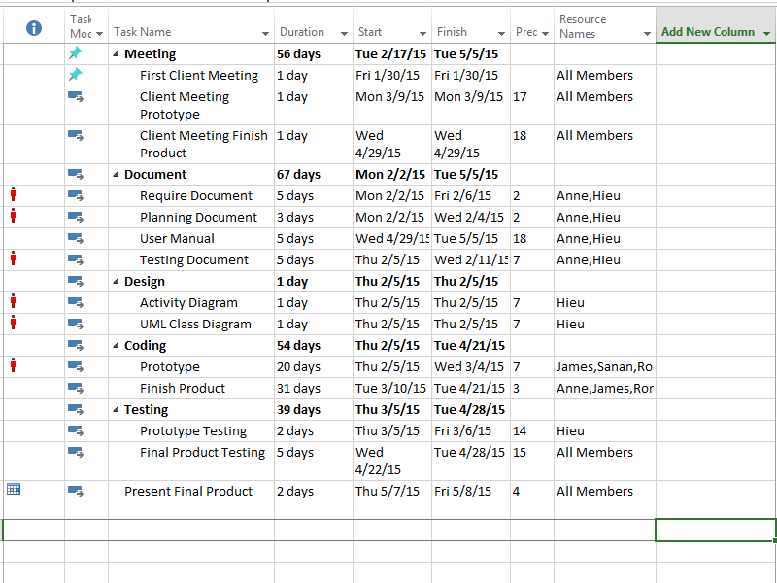

Appendix B - Time Line

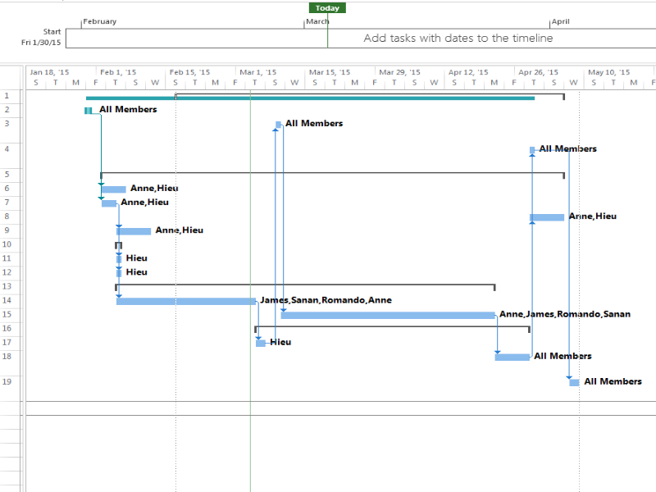

Appendix C – Network Diagram (1 of 2)

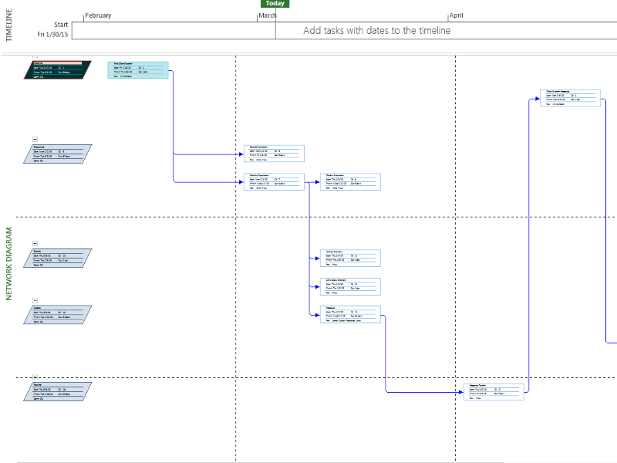

Appendix C – Network Diagram (2 of 2)

